36.31: 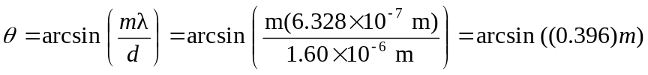
All other m-values lead to angles greater than 